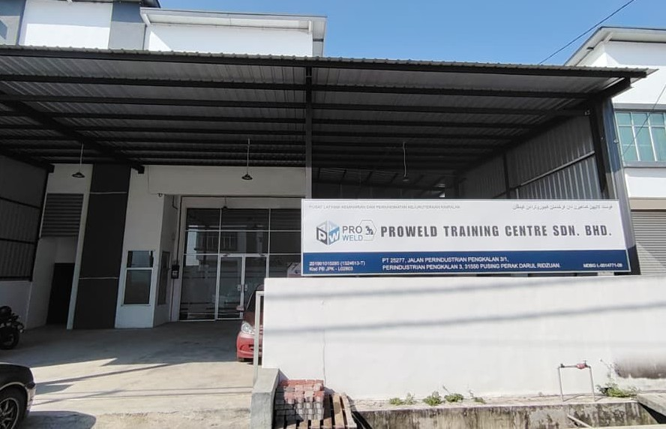






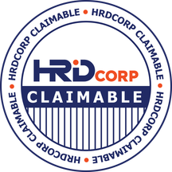

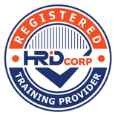



Proweld Training Centre Sdn. Bhd. SSM Reg. No. : 201901015285 (1324613-T) SST Reg. No.: A10-2403-32000104
JPK Accreditation Centre Code: L02803

Company Profile

No. 22, Jalan Perindustrian Pengkalan 3/1, Kawasan Perindustrian Pengkalan 3, 31550 Pusing, Perak Darul Ridzuan.
Tel No.: (+605) 365 2114 | (+6010) 233 3031
Email Address: infopwtc@gmail.com Proweld Training Centre Sdn. Bhd. proweld_official
Proweld Training Centre



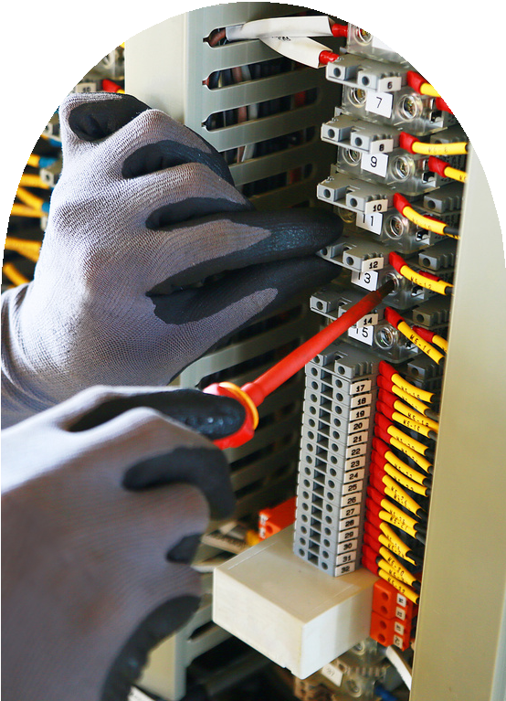
Proweld Training Centre Sdn. Bhd.

Table of Contents

About Us
Vision & Mission
Our Corporat Statement Our Services
List of Training Certification Bodies List of Service Standard Bodies Management Team Our Facilities Welding Training Automation Training Automotive Training Electric Training Forklift Training TVET Kidz
Partnerships & Clients Contact Us

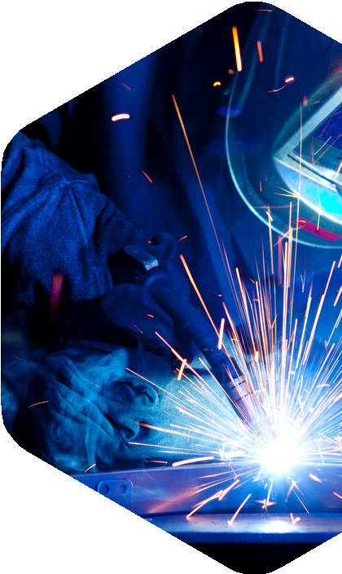

Proweld Training Centre Sdn. Bhd.

About Us

Established in 2019, Proweld Training Centre Sdn. Bhd. is committed to developing skilled, industry-ready talent in welding and technical fields. Through strategic collaborations with leading industrial associations in Perak such as PFEIA and PCCCCI, as well as various industry partners, Proweld ensures its training remains relevant to current industry needs.
Equipped with modern facilities, including welding simulators, the centre provides a practical and hands-on learning experience for trainees. Proweld is also accredited by recognized bodies such as Jabatan Pembangunan Kemahiran Malaysia (JPK), HRD Corp, and CIDB Malaysia, reflecting its high training standards.
Supported by experienced and certified trainers, Proweld continues to play a vital role in empowering individuals and supporting industry growth through quality training and skills development.

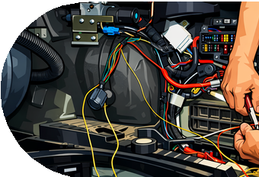
Proweld Training Centre Sdn. Bhd.

Vision & Mission

 Vision

We will be one of the leading companies in the country to provide the maintenance services, and the best and most reliable consultation for Welding, teaching and maintenance programmes for economics development in Malaysia and beyond.

 Mission

PROWELD's mission is to create opportunities and enrich people's lives through excellence training programs. Proweld plays a critical leadership role for clients and the government sector by promoting and supplying quality products and complete reliability with the best service in Malaysia.

Proweld Training Centre Sdn. Bhd.

Our Corporate Statement

Core Values

Corporate Strategy

Quality Policy
Focuses on employees and strive to build skills and competencies in individual and capabilities for the organization

Proweld leads to qualifications in all aspects of welding, theory and practice towards the production of local and international workforce

Provide support to quality improvement of welding education and training in Malaysia and surrounding areas




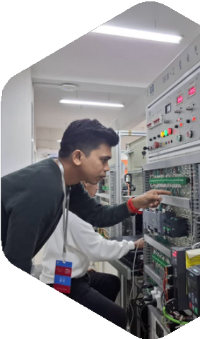
Proweld Training Centre Sdn. Bhd.

Our Services

Training
Welding Technolgy
Mechatronic (Automation) Technology Automotive Technology
Electronic & Electric Occupational Safety and Health

Services
WPS Development Welding Inspection Welding Coordinator NDT & DT Test Lab NDT Ultrasonic

SKM L3 Automotion Basic Welding
Proweld Training Centre Sdn. Bhd.
List of Training
SKM L3 Welding Technology
Weling Machine Maintenance  Welding Qualification Test
NDT & DT Training Plasma Cutting
Automation Training
PLC Programming Training Automotive Training
Electric and Electronic Training Safety and Health

CSWIP
Proweld Training Centre Sdn. Bhd.
Certification Bodies
Jabatan Pembangunan Kemahiran Malaysia
American Society for Nondestructive Testing (ASNT)
Bereau Veritas CIDB Malaysia

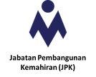
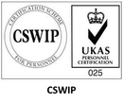
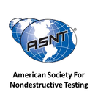
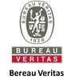
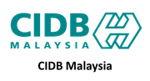

Welding Coordinator NDT & DT Lab
Proweld Training Centre Sdn. Bhd.
List of Services
NDT & DT Testing
Weling Machine Maintenance Welding Qualification Test
WPS Development
Supply Welding Equipment Welding Manpower

Standard & Industrial Research Institute of Malaysia (SIRIM)
Proweld Training Centre Sdn. Bhd.

Standard Bodies
Jabatan Pembangunan Kemahiran Malaysia
National Occupational Skills Standard (NOSS)
American Welding Socienty (AWS)
American Society of Mechanical Engineering (ASME)
American Standard Testing Metal (ASTM) American Petroleum Institute (API)
International Standard Organization (ISO) British Standard (BS)

Proweld Training Centre Sdn. Bhd.

Management Team

Aziratul Famieza


Centre Manager

Tc. Mohd Hazizul
Managing Director

Shafizul Ezwan
Business Development

Tc. Badrul Hisham
Technical Specialist

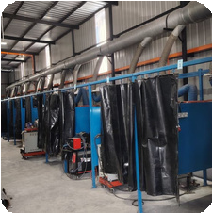
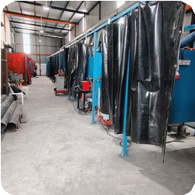
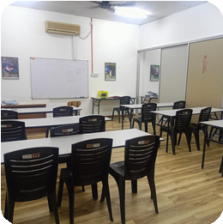
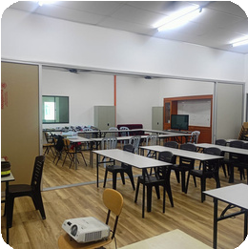
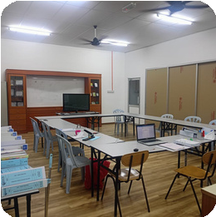
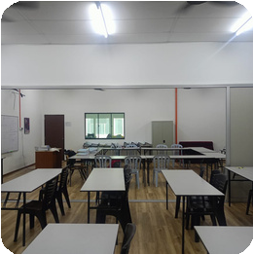
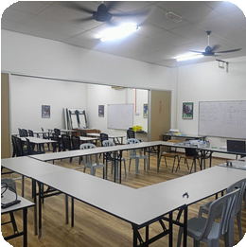
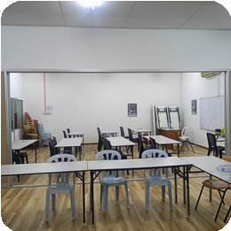
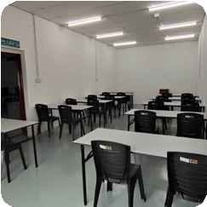
Proweld Training Centre Sdn. Bhd.

Our Facilities

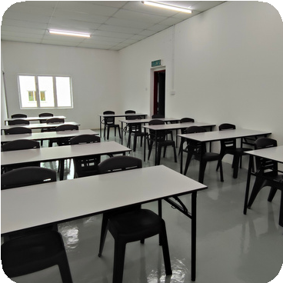
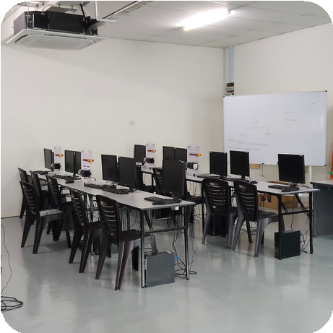
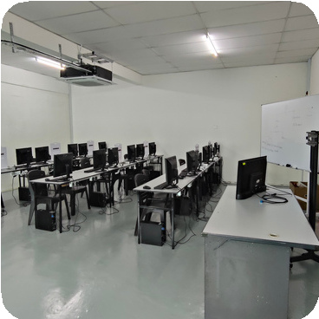
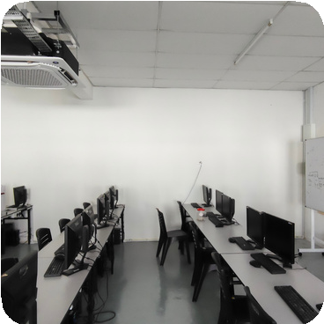
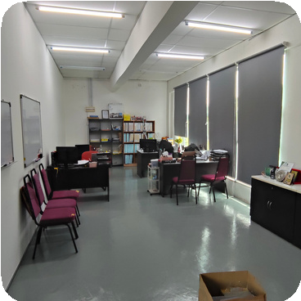
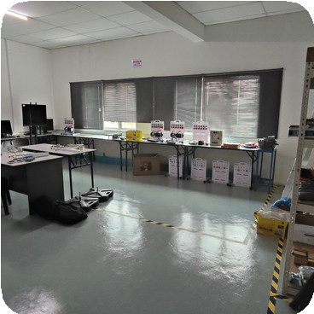
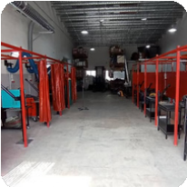
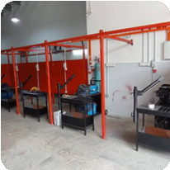
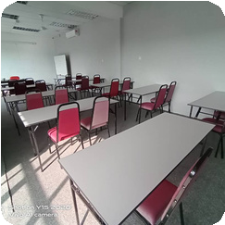
Proweld Training Centre Sdn. Bhd.

Our Facilities

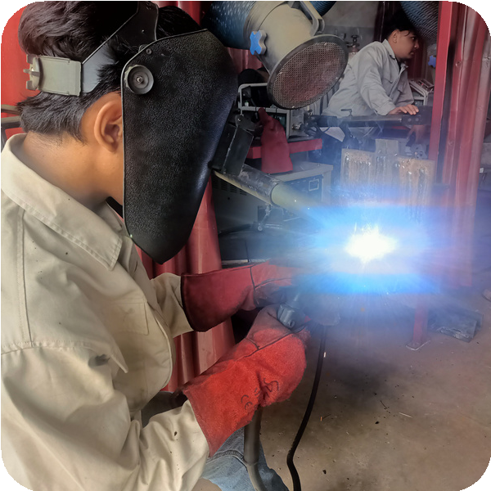
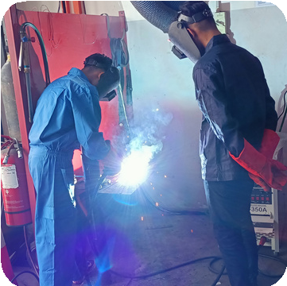
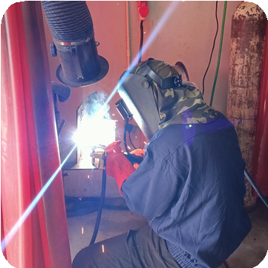
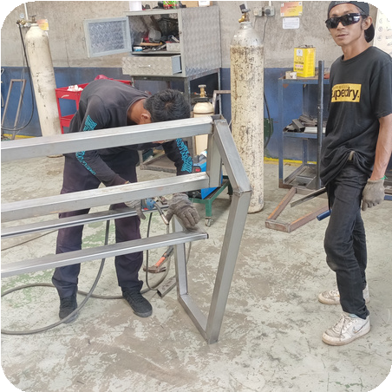
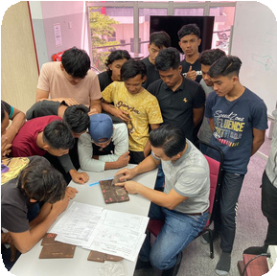
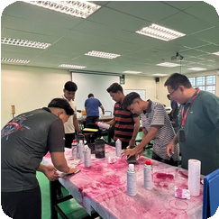
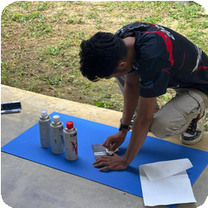
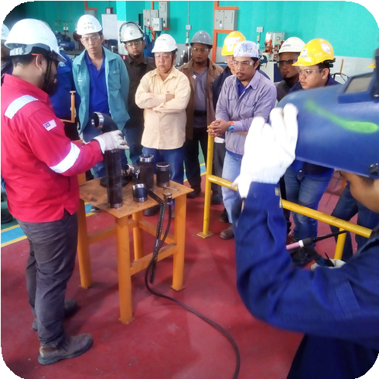
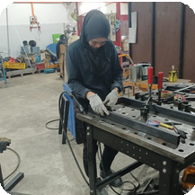
Proweld Training Centre Sdn. Bhd.

Welding Training

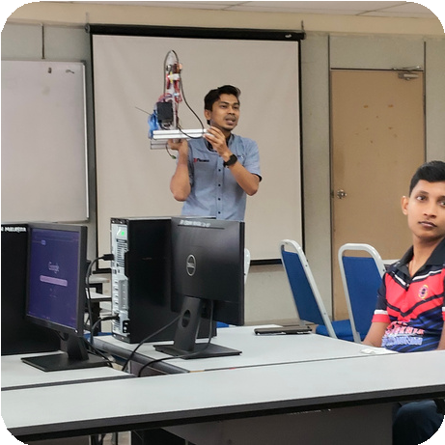
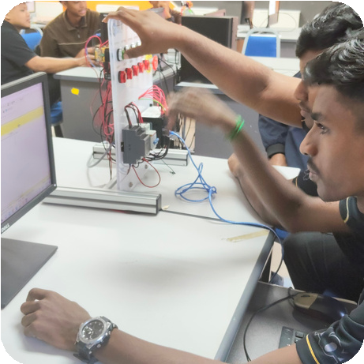
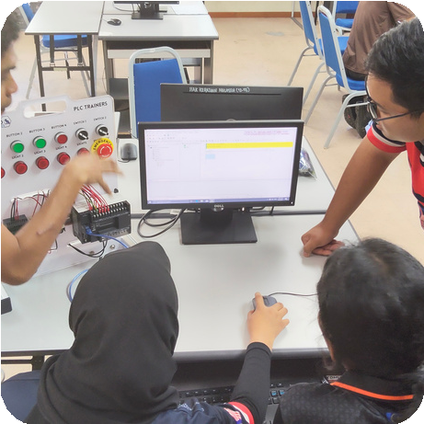
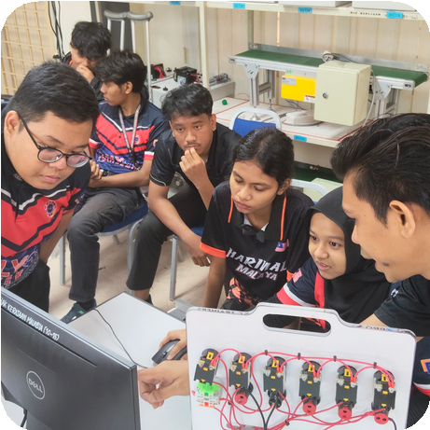
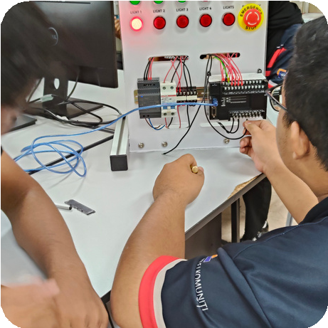
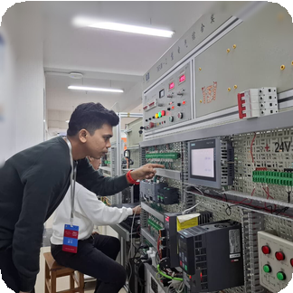
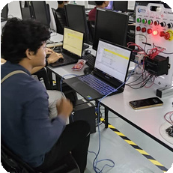
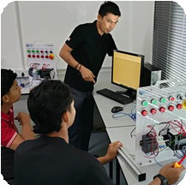
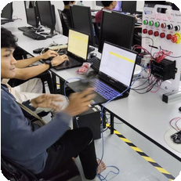
Proweld Training Centre Sdn. Bhd.

Automation Training

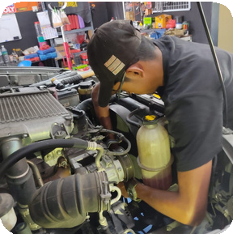
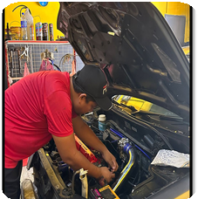
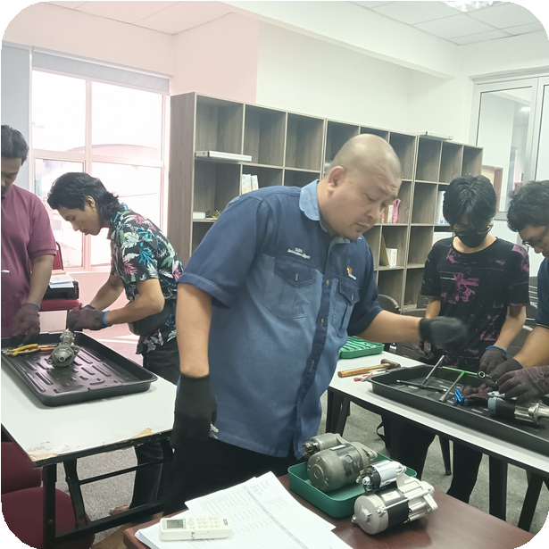
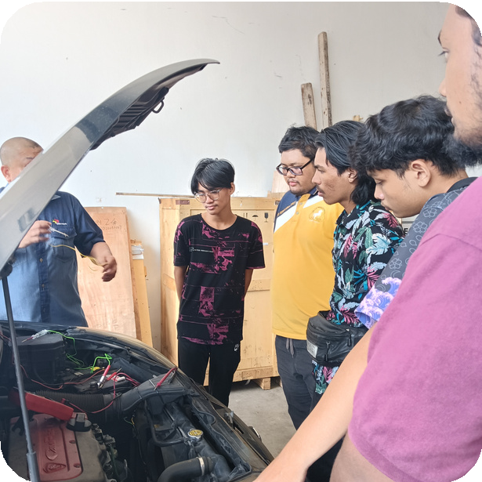
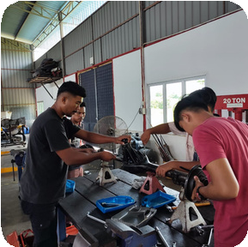
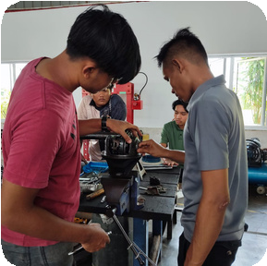
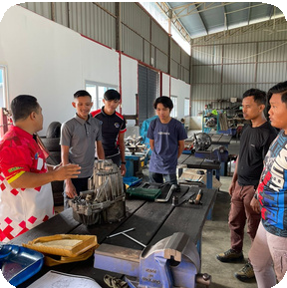
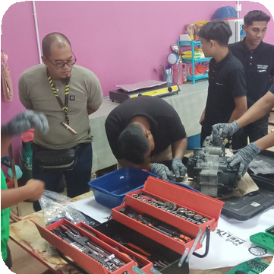
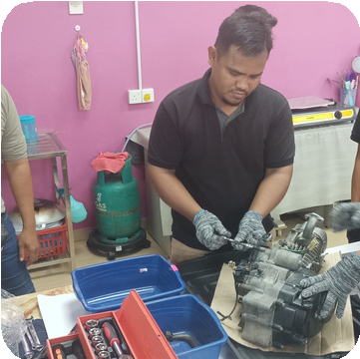
Proweld Training Centre Sdn. Bhd.

Automotive Training

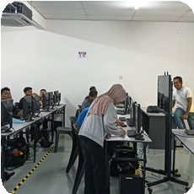
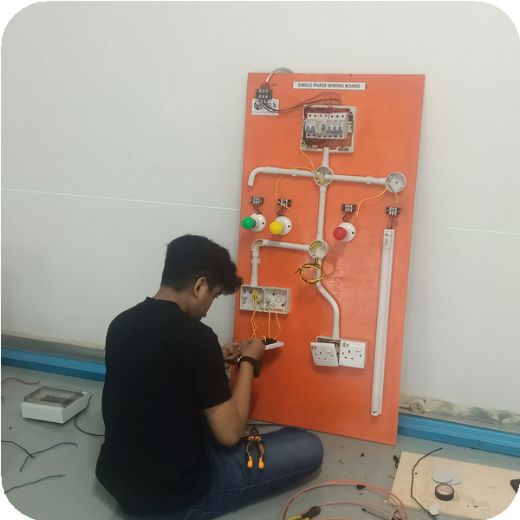
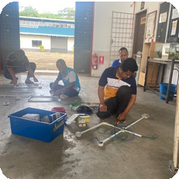
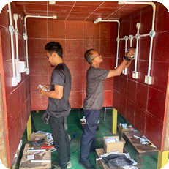
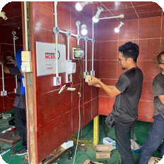
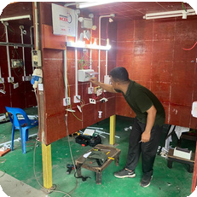
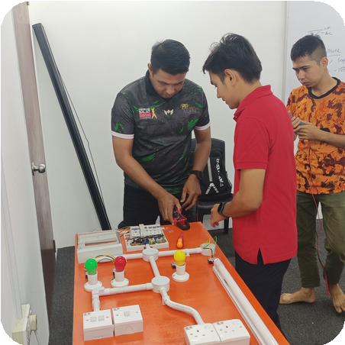
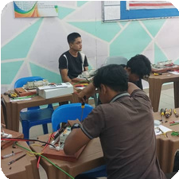
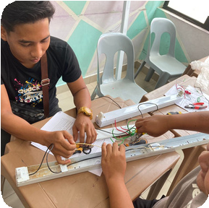
Proweld Training Centre Sdn. Bhd.

Electric Training

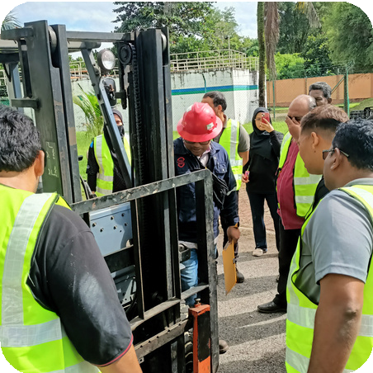
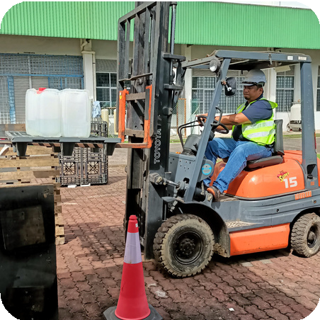
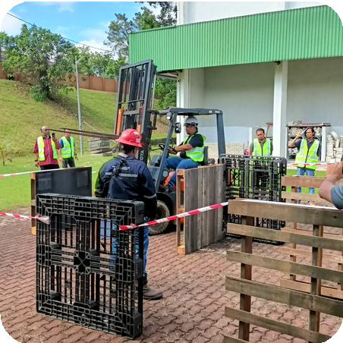
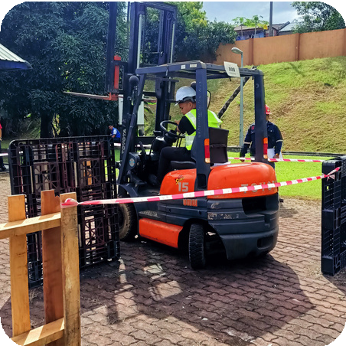
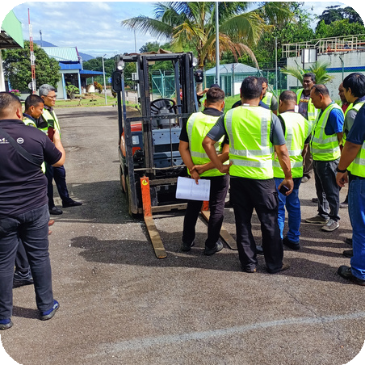
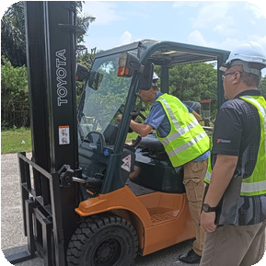
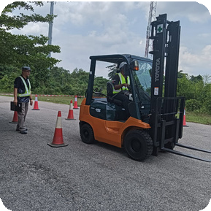
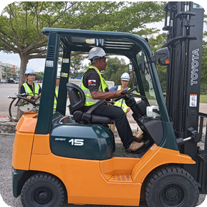
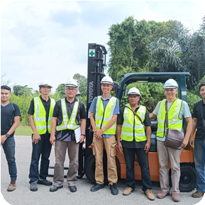
Proweld Training Centre Sdn. Bhd.

Forklift Training

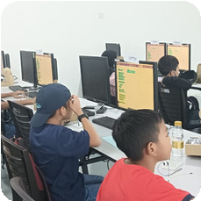
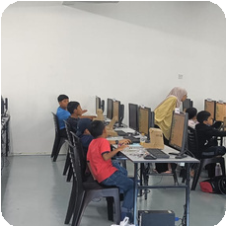
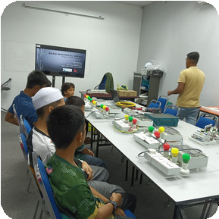
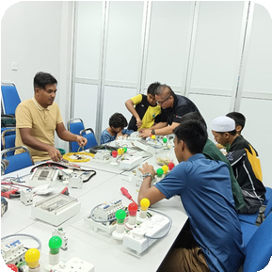
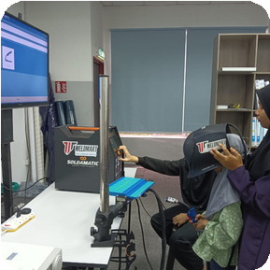
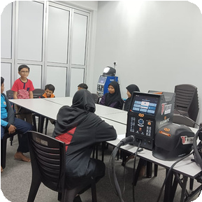
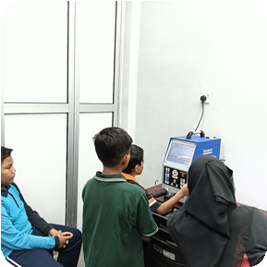
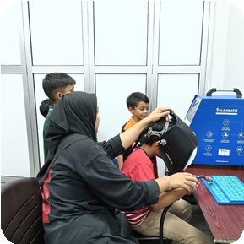
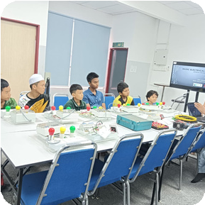
Proweld Training Centre Sdn. Bhd.

TVET Kidz






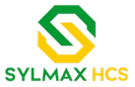
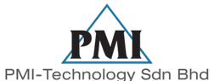


Proweld Training Centre Sdn. Bhd.





Partnerships & Clients














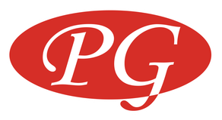






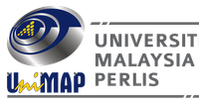
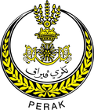
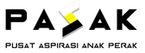

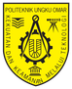
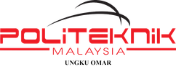

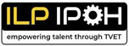
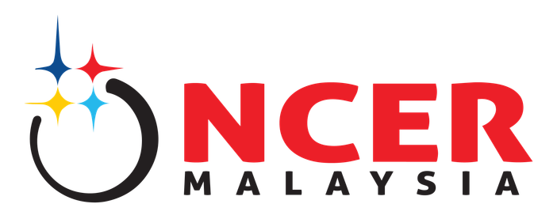

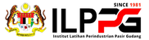



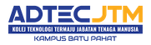



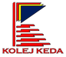


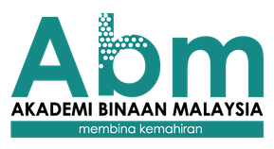
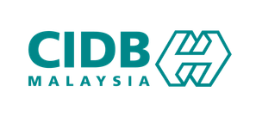


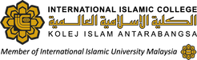
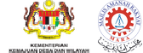


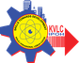
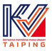







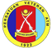

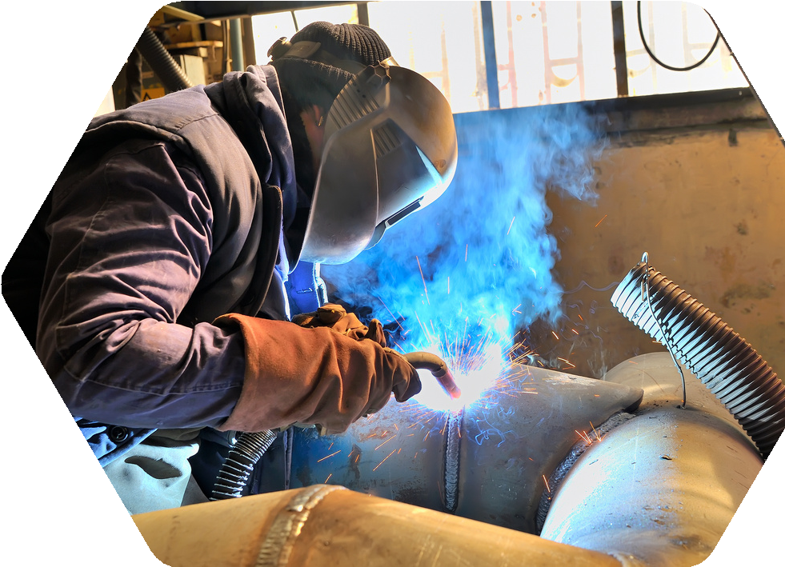





Proweld Training Centre Sdn. Bhd.

Contact Information

(+6010) 230 3031
infopwtc@gmail.com www.weldmart.com
No. 22, Jalan Perindustrian Pengkalan 3/1 Kawasan Perindustrian Pengkalan 3 31550 Pusing, Perak




Proweld Training Centre Sdn. Bhd. proweld_official Proweld Training Centre

